**Documentation of our website**

**TechTrio-Freelance Agency**

|  |  |
| --- | --- |
| Group member name | Roll number |
| Amama Jawaid | 21sw029 |
| Rida Shah | 21sw059 |
| Kashish Kumari | 21sw074 |
|  |  |

* **Overview**

This repository encompasses the source code for the TechTrio Freelance Agency website, a dynamic platform committed to delivering top-notch IT solutions. TechTrio brings together a group of seasoned professionals with a wealth of experience in the IT industry. Employing innovative technologies, the agency is dedicated to creating a digital environment where clients can thrive.

* **Mission**

At TechTrio, our mission is to provide cutting-edge IT solutions that empower businesses and contribute to societal progress. With a focus on adaptability and innovation, we continuously strive to deliver the best possible outcomes for our clients.

* **Expertise**

As a leading freelance agency based in Pakistan, TechTrio specializes in a wide range of IT services, including software development, mobile app development, software quality assurance, digital marketing, web development, and creative designing. Our diverse expertise allows us to tailor solutions that precisely meet the unique needs of our clients.

* **User-Friendly Design**

The TechTrio website features a user-friendly design, providing a seamless experience for visitors across all devices. Whether you're exploring our services on a desktop, tablet, or smartphone, our responsive design ensures accessibility and functionality.

* **Features**

The website features static pages like Home, About Us, Services, Meet our Team, and Contact Us. Its responsive design ensures accessibility across devices, and an intuitive navigation menu simplifies user interaction. Notably, SVG graphics are employed, providing scalable icons for an enhanced visual experience.

* **Technologies Used**

HTML is used for structuring the website content, while CSS provides styling and enables responsive design.

* **Setup**
* To run this website locally, follow these steps:
* Clone the repository to your local machine.

git clone https://github.com/amamavirk03/scdweb

* Open the index.html file in your web browser.
* **Structure**
* index.html - The landing page introducing TechTrio Freelance Agency.
* about.html - The About Us page providing insights into TechTrio's mission, commitment, and team.
* services.html - The Services page detailing the diverse IT services offered by TechTrio.
* team.html - The Meet our Team page showcasing key team members and their expertise.
* contact.html - The Contact Us page with essential contact information and a form for inquiries.
* css/styles.css - The stylesheet defining the website's styling and ensuring responsiveness.

1. Landing Page 🡪 index.html

* **Hero Section**

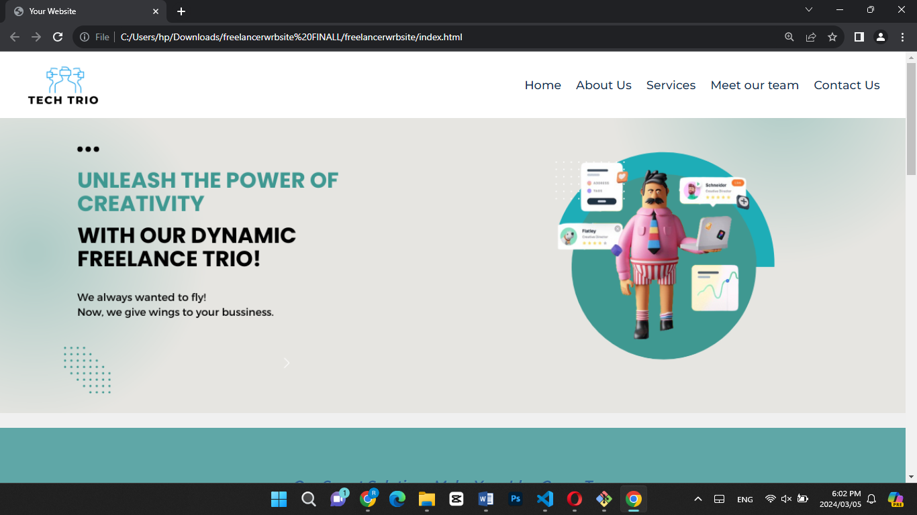

* **Another Section**

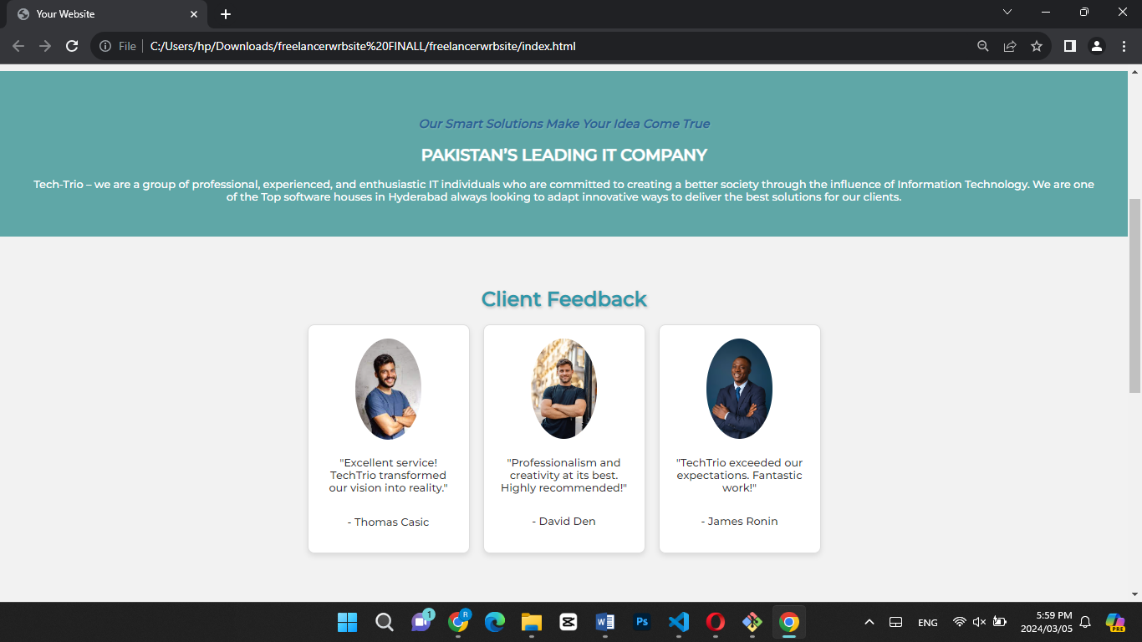

* **Client Feedback section**

## 

* **Packages, Company stats and Footer**

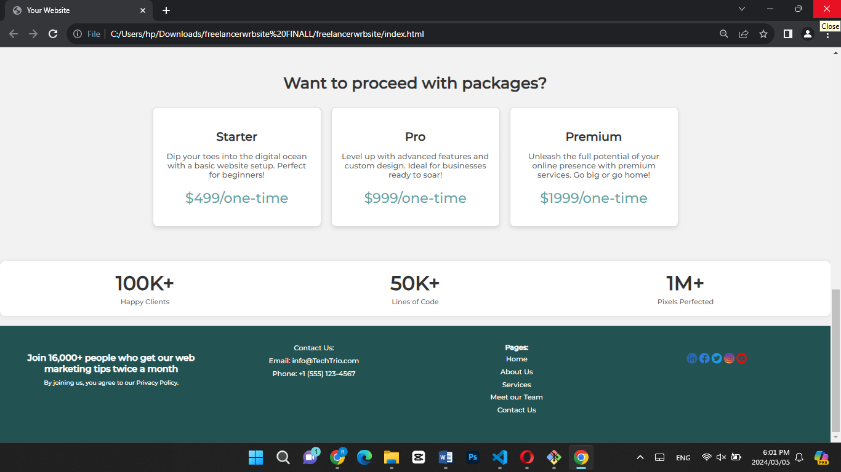

**The implementation of the approach:**

**HTML Document Components:**

1. <!DOCTYPE html>: Declaration specifying the HTML version.

2. <html lang="en">: Root element defining the document type and language.

3. <head>: Container for metadata such as character set, viewport settings, and title.

<meta charset="UTF-8">: Character encoding declaration.

<meta name="viewport" content="width=device-width, initial-scale=1.0">: Viewport settings for responsive design.

<title>Your Website</title>: Title of the HTML document.

<link rel="stylesheet" href="style.css">: Link to an external CSS stylesheet.

4. <body>: Main content area of the HTML document.

<header>: Header section containing the logo and navigation menu.

<img src="TECHTRIO-removebg-preview.png" alt="Your Logo">: TechTrio logo.

<nav>: Navigation menu with links to Home, About Us, Services, Meet our Team, and Contact Us

5. `</body>`: End of the document's body.

6. `</html>`: End of the HTML document.

**CSS Styles:**

1. Apply styling to all elements using the `*` selector for a consistent box model.
2. Style the `body` element with specific font family, background color, and text alignment.
3. Define styles for elements with the class "available," configuring them as a flex container with centered items.
4. Customize the appearance of the `select` element within elements having the class "available," adjusting background color, text color, and width.
5. Style `button` elements, specifying attributes like margin, cursor, padding, background color, text color, border, and border-radius.
6. Add hover styles for `button` elements to enhance the user experience.
7. Implement a media query for screens with a maximum width of 600 pixels, adjusting the width of the `select` element within the "available" class for better responsiveness.

2. About Us Page 🡪 aboutus.html

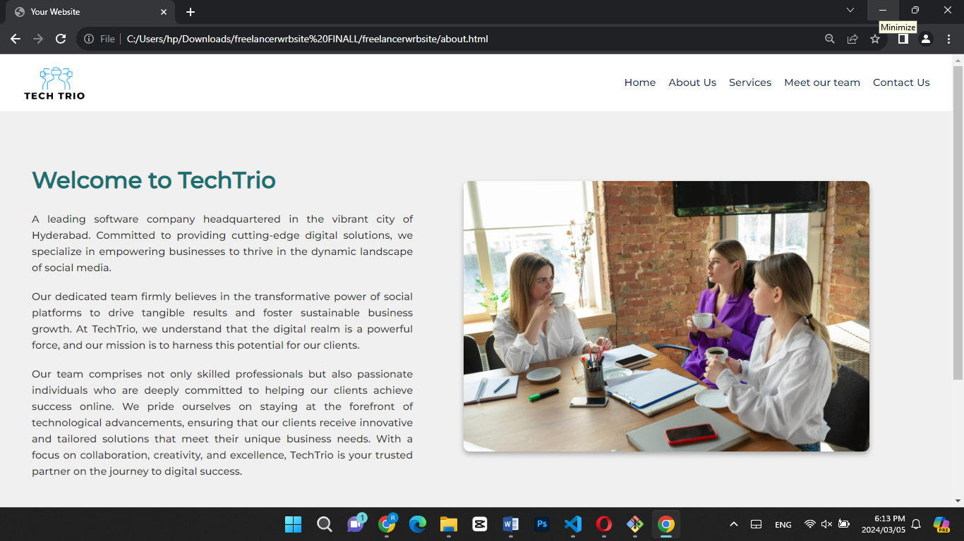

**HTML Document Components:**

1. `<!DOCTYPE html>`: Declaration specifying the HTML version.

2. `<html lang="en">`: Root element defining the document type and language.

3. `<head>`: Container for metadata such as character set, viewport settings, and title.

- `<meta charset="UTF-8">`: Character encoding declaration.

- `<meta name="viewport" content="width=device-width, initial-scale=1.0">`: Viewport settings for responsive design.

- `<title>About Us | TechTrio</title>`: Title of the HTML document.

- `<link rel="stylesheet" href="https://fonts.googleapis.com/css2?family=Montserrat:wght@500&display=swap">`: Link to an external font stylesheet.

4. `<body>`: Main content area of the HTML document.

- `<div class="about-section">`: Container for the entire "About Us" section.

- `<div class="content">`: Container for textual content.

- `<h2>Welcome to TechTrio</h2>`: Heading for the section.

- `<p>`: Paragraphs providing information about TechTrio.

- `<div class="image">`: Container for the image.

- `<img src="about us image.jpg" alt="About Us Image">`: Image displaying visuals related to TechTrio.

- `<footer>`: Footer section containing additional information.

- `<div class="web-marketing">`: Container for web marketing details.

- `<div class="contact-info">`: Container for contact information.

- `<div class="page-details">`: Container for page-related details.

- `<p><a href="index.html" style="color: #fff; text-decoration: none;">Home</a></p>`: Navigation link to the Home page.

- Other similar navigation links for different pages.

- `<div class="social-icons">`: Container for social media icons.

**CSS Styles:**

1. `body`: Styling for the body element.

- `margin: 0; padding: 0;`: Resets default margin and padding.

- `font-family: 'Montserrat', sans-serif;`: Applies the Montserrat font family.

- `background-color: #1a7070; color: #fff;`: Background color and text color for the body.

2. `.about-section`: Styling for the "About Us" section.

- `display: flex; justify-content: space-between; align-items: center;`: Flexbox layout for content alignment.

- `padding: 50px;`: Adds padding to the section.

3. `.content`: Styling for the content container.

- `flex: 1; max-width: 600px; line-height: 1.6;`: Flex properties, maximum width, and line height for text content.

4. `.content h2`: Styling for the heading.

- `font-size: 36px; margin-bottom: 20px; color: #1a7070;`: Font size, margin, and color for the heading.

5. `.content p`: Styling for paragraphs.

- `font-size: 16px; margin-bottom: 20px; text-align: justify;`: Font size, margin, and justified alignment for paragraphs.

6. `.image`: Styling for the image container.

- `flex: 1; text-align: center;`: Flex properties and center alignment for the image container.

7. `.image img`: Styling for the image.

- `max-width: 80%; border-radius: 10px; box-shadow: 0 4px 8px rgba(0, 0, 0, 0.3);`: Maximum width, border-radius, and box shadow for the image.

8. `footer`: Styling for the footer.

- `padding: 20px; text-align: center;`: Padding and center alignment for the footer.

9. Additional styles for `.web-marketing`, `.contact-info`, `.page-details`, and `.social-icons` containers and their child elements.

- `<link rel="stylesheet" href="style.css">`: Link to an external CSS stylesheet.

- `<title>SNEAKERS</title>`: Title of the HTML document.

- Internal `<style>` block for inline CSS styling.

. `<body>`: Main content area of the HTML document.

- `<div class="image">`: Division containing the brand logo image.

- `<img src="logo/main logo.png" alt="Image not found" class="logo">`: Brand logo image.

- `<nav class="menu">`: Navigation menu containing links to different product categories.

- `<a href="Boots.html">Boots</a>`: Link to the boots category page.

- `<a href="flat.html">Flats</a>`: Link to the flats category page.

- `<a href="boatshoe.html">Boat shoes</a>`: Link to the boat shoes category page.

- `<a href="sneaker.html">Sneakers</a>`: Link to the sneakers category page.

- `<center>`: Center-aligned content container.

- `<h1>`: Heading indicating "Trending".

- `<video src="logo/Trending.mp4" autoplay style="object-fit: cover; height: 100vh; width: 90.5vw;"></video>`: Video element displaying trending content.

- `<h1>`: Heading indicating "Bloggers Spotted".

- `<img src="logo/blogger1.jpg" style="margin-left: 110px;">`: Image of the first spotted blogger.

- `<div class="centered"><h1><a href="sneaker.html">Sneakers</a></h1></div>`: Center-aligned heading with a link to the sneakers category page.

- `<img src="logo/blogger2.jpg" alt="" style="margin-left: -17px; height: 846px;">`: Image of the second spotted blogger.

- `<div class="right"><h1><a href="Boots.html">Boots</a></h1></div>`: Right-aligned heading with a link to the boots category page.

- `<div class="foot">`: Footer section.

- Footer content indicating copyright information.

3. Services Page 🡪 services.html

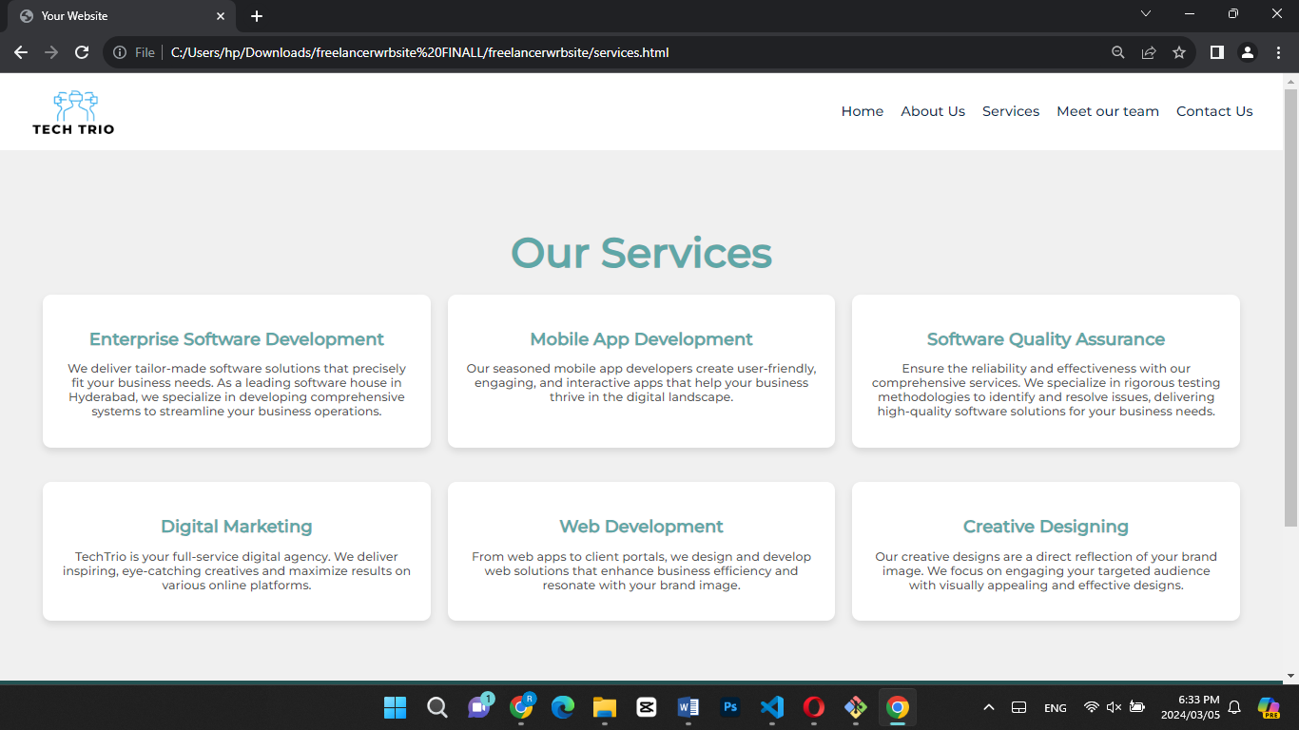

**HTML Document Components:**

1. `<!DOCTYPE html>`: Declaration specifying the HTML version.

2. `<html lang="en">`: Root element defining the document type and language.

3. `<head>`: Container for metadata such as character set, viewport settings, and title.

- `<meta charset="UTF-8">`: Character encoding declaration.

- `<meta name="viewport" content="width=device-width, initial-scale=1.0">`: Viewport settings for responsive design.

- `<title>Our Services | TechTrio</title>`: Title of the HTML document.

- `<link rel="stylesheet" href="https://fonts.googleapis.com/css2?family=Montserrat:wght@500&display=swap">`: Link to an external font stylesheet.

4. `<body>`: Main content area of the HTML document.

- `<div class="services-section">`: Container for the entire "Services" section.

- `<h2 class="services-heading"> Our Services</h2>`: Heading for the section.

- `<div class="service-container">`: Container for service items.

- Service items (multiple):

- `<div class="service">`: Container for an individual service.

- `<h3>`: Heading for the service.

- `<p>`: Description of the service.

**CSS Styles:**

1. `body`: Styling for the body element.

- `margin: 0; padding: 0;`: Resets default margin and padding.

- `font-family: 'Montserrat', sans-serif;`: Applies the Montserrat font family.

- `background-color: #f0f0f0; color: #333;`: Background color and text color for the body.

2. `.services-section`: Styling for the "Services" section.

- `padding: 50px; text-align: center;`: Adds padding and centers the text.

3. `.services-heading`: Styling for the heading.

- `font-size: 48px; color: #5fa7a7; margin-bottom: 20px;`: Font size, color, and margin for the heading.

4. `.service-container`: Styling for the container of service items.

- `display: flex; flex-wrap: wrap; justify-content: center; gap: 20px;`: Flexbox layout with wrapping and centered alignment.

5. `.service`: Styling for an individual service.

- `background-color: #fff; padding: 20px; border-radius: 10px; box-shadow: 0 4px 8px rgba(0, 0, 0, 0.1); transition: transform 0.3s ease-in-out; flex: 1 0 300px; margin-bottom: 20px;`: Background color, padding, border-radius, box shadow, transition, and flex properties for the service container.

- `.service:hover`: Styling for the service container on hover, applying a scale transformation.

- `.service h3`: Styling for the service heading.

- `font-size: 20px; color: #5fa7a7; margin-bottom: 10px; transition: color 0.3s ease;`: Font size, color, margin, and color transition on hover.

- `.service:hover h3`: Styling for the service heading on hover, changing the color.

- `.service p`: Styling for the service description.

- `font-size: 14px; color: #555;`: Font size and color for the description.

3. Meet our team page 🡪 meetourteam.html

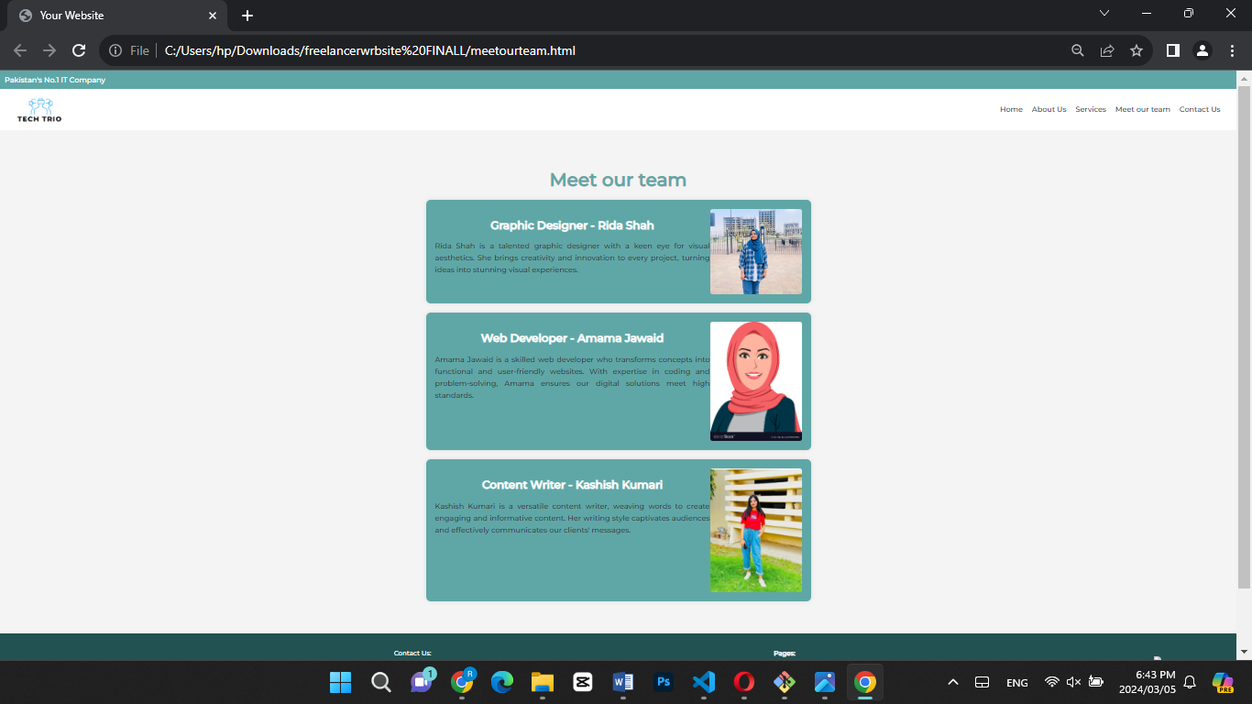

**HTML Document Components:**

1. `<!DOCTYPE html>`: Declaration specifying the HTML version.

2. `<html lang="en">`: Root element defining the document type and language.

3. `<head>`: Container for metadata such as character set, viewport settings, and title.

- `<meta charset="UTF-8">`: Character encoding declaration.

- `<meta name="viewport" content="width=device-width, initial-scale=1.0">`: Viewport settings for responsive design.

- `<title>Your Website</title>`: Title of the HTML document.

- `<link rel="stylesheet" href="https://fonts.googleapis.com/css2?family=Montserrat:wght@500&display=swap">`: Link to an external font stylesheet.

- `<link rel="stylesheet" href="style.css">`: Link to an external style sheet (Adjust the path accordingly).

4. `<body>`: Main content area of the HTML document.

- `<div class="top-statement">`: Container for the top statement.

- Text content: "Pakistan's No.1 IT Company".

- `<header>`: Header section containing the logo and navigation.

- `<img src="TECHTRIO-removebg-preview.png" alt="Your Logo">`: Logo image.

- `<nav>`: Navigation links.

- Navigation links (Home, About Us, Services, Meet Our Team, Contact Us).

- `<div class="services-section">`: Container for the "Meet Our Team" section.

- `<h2 class="services-heading">Meet our team</h2>`: Heading for the section.

- Team members (multiple):

- `<section class="team-member">`: Container for an individual team member.

- `<div class="content">`: Container for text content.

- `<h2>`: Team member's name and role.

- `<p>`: Description of the team member.

- `<img>`: Image of the team member.

- `<footer>`: Footer section containing web marketing, contact information, page details, and social icons.

- `<div class="web-marketing">`: Container for web marketing content.

- Web marketing heading and privacy statement.

- `<div class="contact-info">`: Container for contact information.

- Email and phone information.

- `<div class="page-details">`: Container for page details.

- Pages (Home, About Us, Services, Meet Our Team, Contact Us).

- `<div class="social-icons">`: Container for social icons.

- `<img src="image-removebg-preview (73).png">`: Social icon image.

**CSS Styles:**

The CSS styles have been provided in the original code, including styling for the body, top statement, header, navigation, team section, team members, and footer. The styles define the layout, colors, typography, and spacing for a cohesive design.Footer content indicating copyright information.

1. Contact Us Page 🡪 contactus.html

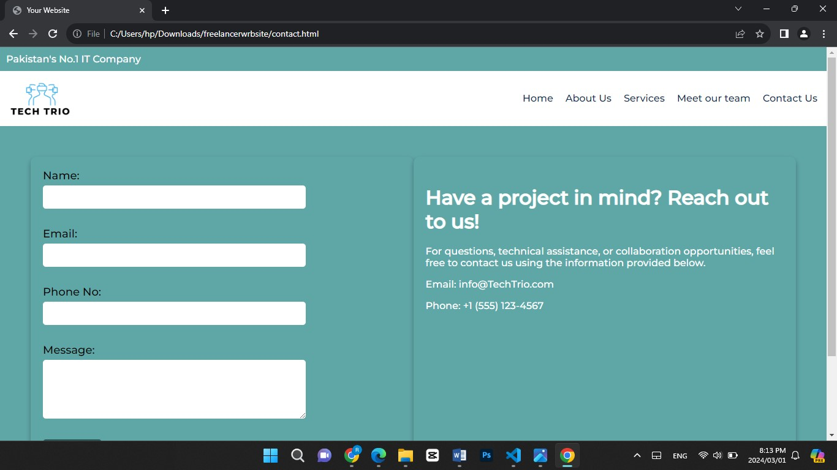

**Contact Page HTML:**

1. HTML Structure:

- Standard HTML5 document structure.

- Head with charset, viewport, title, and external font stylesheet.

- Two main sections: contact form and contact information.

2. Contact Form Section:

- Flex display for layout.

- Form with input fields for name, email, phone, and message.

- Submit button with a distinct style.

3. Contact Information Section:

- Flex layout.

- Project statement (`h2`) and contact details (`p`).

**Contact Page CSS:**

1. Body Styles:

- Font family, margin, padding, background color, and text color.

2. Contact Section Styles:

- Flex display, padding, and space-between alignment.

3. Contact Form Styles:

- Flex property, padding, border-radius, and box-shadow for form container.

- Form group styling for labels and input fields.

- Submit button styling with hover effect.

4. Contact Information Styles:

- Flex property, padding, background color, border-radius, and box-shadow.

- Font size and color adjustments for statement and contact details.

Footer Styles:

- Flex display, padding, and space-between alignment.

- Styling for web marketing, contact info, page details, and social icons.

- Hover effect for page details links and a specific width for social icons.